**Rabat, Morocco Presents its First Art Biennale**

***‘An Instant before the World’***

Opening on the 24th of September 2019

Professional Days 23rd and 24th of September 2019

**Under the high patronage of His Majesty King Mohammed VI, the** **National Foundation of Museums of the Kingdom of Morocco presents the first edition of the Rabat Biennale. The Biennale is organised in the Moroccan capital, from September 24th to December 18th, 2019. It was designed by the art historian and philosopher Abdelkader Damani, the guest curator.**

The theme of the inaugural Rabat Biennale is ***‘An Instant before the World’*** and will explore artistic practices and art history from the perspective of the Global South taking the city of Rabat – which was appointed “City of light” and cultural capital of Morocco - as its starting point. This inaugural biennale will create a dialogue across artistic disciplines from the visual arts and architecture to dance and performance and seeks to tease out some of the complexities related to the urgent need for creativity by examining the reasons, revolts, and decisive moments that drive artists to take action and contribute to the making of history.

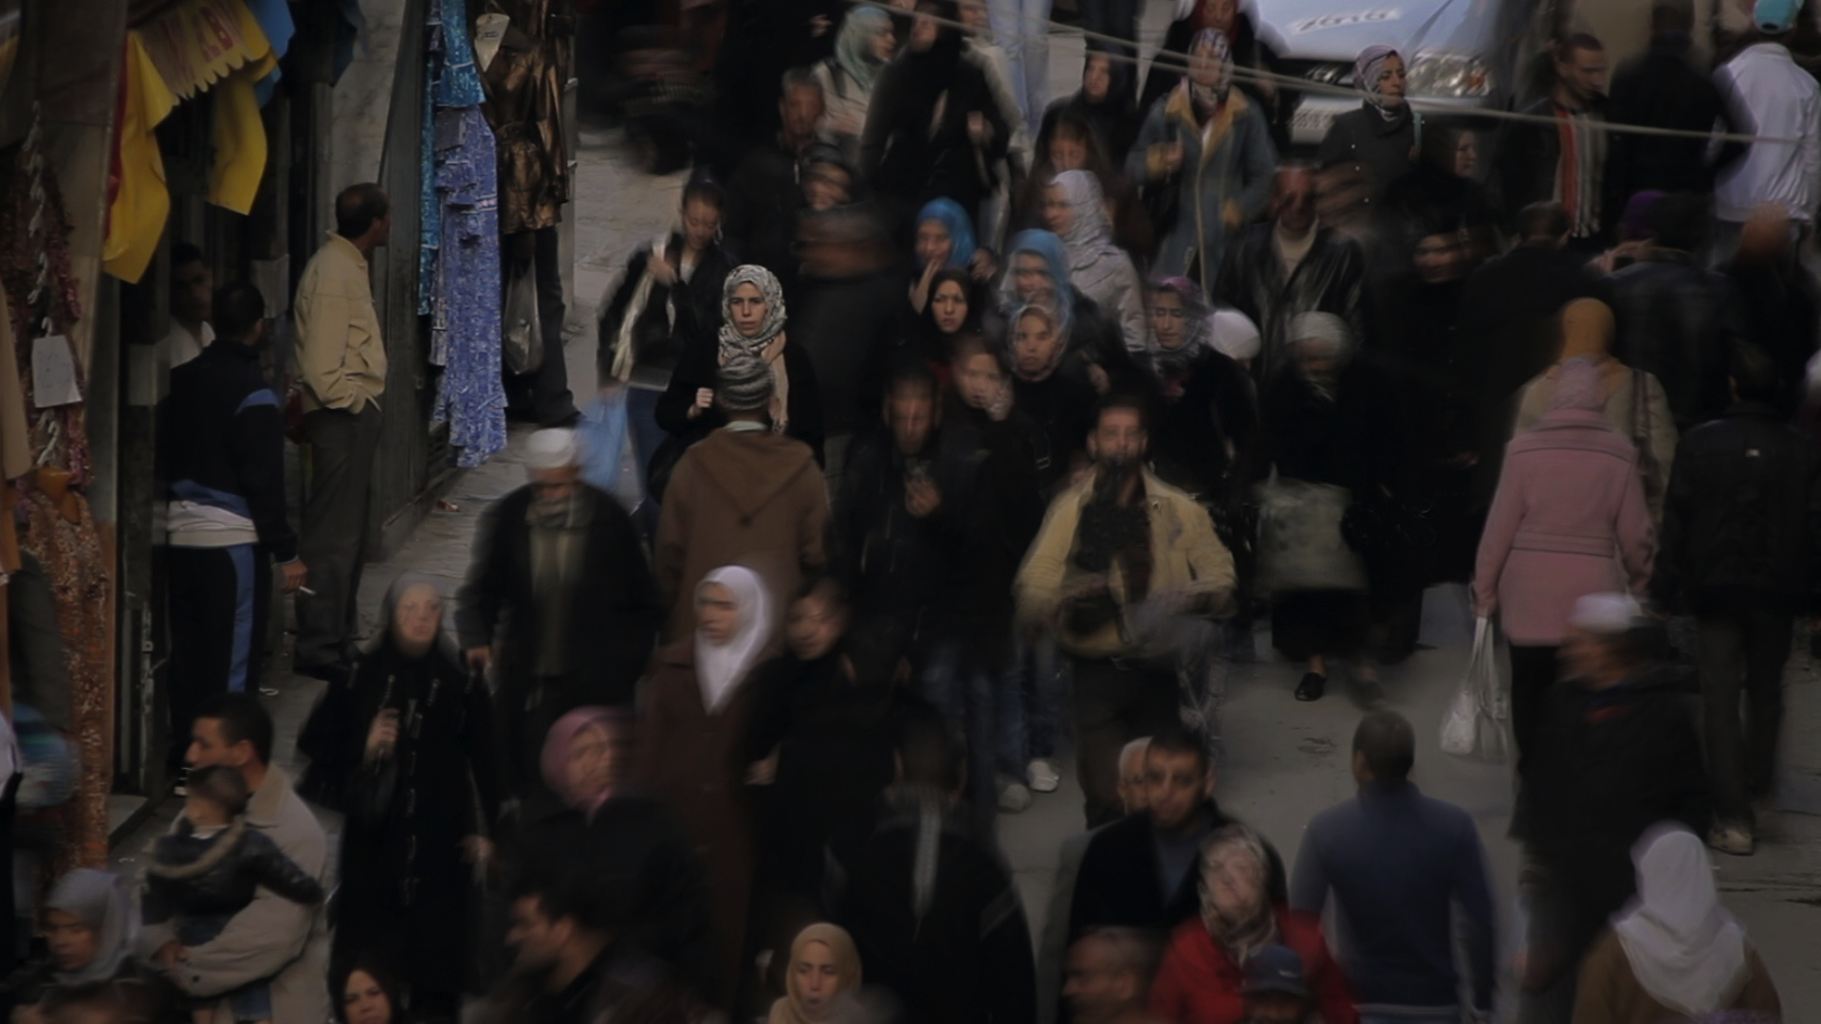

Bahïa Bencheikh-El-Fegoun and Meriem Achour Bouakkaz : *H’na Barra (Nous, dehors)* 2014. (Film) Courtesy of the artist ©Allers-Retours Films

Carried by committed women and men, the Biennale is conceived as a possible inventory of the world of tomorrow and shaped as an archipelago, including the international exhibition and a tryptic of ‘cartes blanches’. In addition, a program of performances and a cultural program will take place throughout the Biennale.

For the first edition of the Biennale, the National Foundation of Museums will organize a focus on Urban Art.

***‘An Instant before the World’* International exhibition**

**The international exhibition**,dedicated entirely to women artists, is set across significant cultural sites in Rabat. It brings together 63 artists and artist collectives, from 27 different nationalities and disciplines. Among them,visual artists and painters (Mona Hatoum, Etel Adnan, Marcia Kure, Ghada Amer, Zoulikha Bouabdellah, Amina Benbouchta, Candice Breitz …), sculptors (Sara Favriau, Ikram Kabbaj), filmmakers and videographers (Tala Hadid, Habiba Djahnine…), choreographers, stage directors and performers (Bouchra Ouizguen, Séverine Chavrier…), photographers (Deborah Benzaquen, Mouna Jemal Siala), digital artists (Naziha Mestaoui), and architects (BLACK SQUARE, Manthey Kula, Zaha Hadid, Maria Mallo…).

Among the Biennale’s highlights, will be a vibrant tribute paid to the Egyptian singer, **Oum Kalthoum**, the first artist selected by the curator, Abdelkader Damani when he was invited to curate this inaugural edition. A projection of her celebrated concert in Rabat in 1968 will be on display at the Biennale.

**A tryptic of ‘Cartes Blanches’ around the International exhibition**

**Three “cartes blanches”**, were given by the curator to leading Moroccan artists and will further inform Rabat Biennale’s questioning of traditional art historical norms:

- **Visual arts**, Carte Blanche to **Mohammed El Baz**

from 24 September to 18 December at the Mohammed VI Museum

For his Carte Blanche, Moroccan artist Mohamed El Baz invites six young artists from the Moroccan art scene to participate in a collective exhibition under the title ***A Forest / La Forêt / El Ghaba*** at the of Mohamed VI Museum. These artists are: Saïd Afifi, M’barek Bouhchichi, Safaa Erruas, Maria Karim, Youssef Ouchra, and Ilias Selfati. By choosing the forest as the central theme of the exhibition, Mohamed El Baz will invite the public to think about the genesis of works of art as well as the many mysteries of the creative process.

- **Cinema**, **Narjiss Nejjjar**

screening every Saturday throughout the Biennale

Moroccan director and Head of the Cinémathèque marocaine (the Moroccan film institute) Narjiss Nejjar will present a film program that will offer a platform to lesser-heard voices in the world of cinema and the many diverse ways in which filmmakers approach the world around us and will include masterclasses and panel discussions with leading directors.

"Cinema is in life and life is in cinema," says Narjiss Nejjjar. She adds, "To welcome a film is to hand out a part of oneself, often unknown to us or sometimes denied. »

- **Literature,** **Faouzia Zouari and Sanae Ghouati**,

in partnership with the Académie du Royaume du Maroc on the 18th of December 2019

To conclude the Biennale, an invitation has been sent to writers, novelists, poetesses and essayists to form the “Assembly of Writers”. The Assembly will bring together nearly 50 women writers who will respond to the themes and discussions of the Biennale under the aegis of Sanae Ghouati, professor at Ibn Tofaïl University and Tunisian novelist Faouzia Zouari.

**Urban Art, National Foundation of Museums**

For several years, the National Foundation of Museums has supported the development of urban arts. Rabat Biennale will showcase the city’s rich urban and street art scene. Street artist **Futura** together with young Moroccan artists will perform a new work at Hassan II park at the opening week of the Biennale.

**Cultural program and mediation**

Debates and seminars: **Two seminars** will take place throughout the Biennale

- *"From Africa, Acting on the definition of Art"*, the first encounter on this issue will take place on the 27th of September 2019. **Nadira Laggoune**, Director of the MAMA in Algiers will ensure the scientific direction of the debate.

- *"Subversive Tenderness",* on December 17th2019, scientific direction of the debate by Abdelkader Damani

Cultural mediation

The mediation courses are design as a wandering within the biennial. Both physical and fictional, the walks from one place to another will follow a simple retinal logic, unfolding in a ternary chromatic mapping: white, brown and blue. The three colours of Rabat.

The cultural program will include theatre plays, music concerts, art workshops, etc. throughout the Biennale.

**Rabat and its Biennale**

In 2012 the city of Rabat became a UNESCO World Heritage Site and the Biennale is set across its many of historic and artistic locations. Sites include major heritage sites including Rottembourg Fort (Borj Lakbir) overlooking the Atlantic Ocean and the historic site and museum of the Udayas as well as leading contemporary arts spaces from the Mohammad VI Museum of Modern and Contemporary Art, la Villa des Arts, to the Espace Expressions CDG, and the exhibition spaces of *Crédit Agricole* and the *Banque Populaire*.

A city that celebrates its rich and varied past and present, Rabat is the manifestation of influences from the Arab world and Mediterranean and it is the dialogue between cultures that the Biennale echoes.

**QUOTES**

Abdelkader Damani, Curator, said; ***“****I wanted to take advantage of the blank page of a first edition and to think of the Biennale as offering a different perspective. The Rabat Biennale is an attempt to offer from the extreme west of the African continent a new world. It is here, one evening in Rabat that the title of this first edition came to me “An Instant before the World.”*

Mehdi Qotbi, President of the National Foundation of Museums in Morocco said; *“With the Rabat Biennale our country has a great creative laboratory dedicated to all forms of arts and conceived of as a space of reflection for artists from all the corners of the globe. I hope that Rabat Biennale will quickly become one of the major international events as it participates in the rewriting of art history from the perspective of the Global South.”*

**ARTISTS OF THE INTERNATIONAL EXHIBITION**

Rand ABDUL JABBAR (Iraq), Etel ADNAN (Lebanon), Amina AGUEZNAY (Morocco), Rita ALAOUI (Morocco), Diana AL HADID (Syria), Lara ALMARCEGUI (Spain), Ghada AMER (Egypt), Dana AWARTANI (Palestine), Ila BEKA & Louise LEMOINE (France), Amina BENBOUCHTA (Morocco), Nadia BENBOUTA (Algeria), Bahia BENCHEIKH-EL-FEGOUN (Algeria), Deborah BENZAQUEN (Morocco), Tatiana BILBAO (Mexico), BLACK SQUARE (Italy), Zulikha BOUABDELLAH (France-Algeria), Halida BOUGHRIET (France-Algeria), Candice BREITZ (South Africa), CELLE QUI MANQUE (Algeria), Hania CHABANE (Algeria), Clémentine CHALENÇON (France), Hejer CHARF (Tunisia- Canada), Séverine CHAVRIER (France), Katharina CIBULKA (Austria), DAAR - Sandi HILAL & Alessandro PETTI - (Palestine), Habiba DJAHNINE (Algeria), EMOUVANCE DES EMOUVANTS (Tunisia), Safaa ERRUAS (Morocco), FEMINIST ARCHITECTURE COLLABORATIVE ( United States), Sara FAVRIAU (France), Tala HADID (Morocco), Zaha HADID (Iraq), Clarisse HAHN (France), Milhumbe HAIMBE (Zambia), Mona HATOUM (Palestine), Mouna JEMAL SIALA (Tunisia), Oum KALTHOUM (Egypt), Katia KAMELI (France-Algeria), Amal KENAWY (Egypt), Majida KHATTARI (Morocco), Lucia KOCH (Brazil), Marcia KURE (Nigeria), Brigitte MAHLKNECHT (Austria), María MALLO (Spain), Natasha MEGARD (France), MANTHEY KULA (Norway), Lucy MCRAE (United Kingdom), Naziha MESTAOUI (Belgium), Julie NIOCHE (France), Adjaratou OUEDRAOGO (Burkina Faso), Bouchra OUIZGUEN (Morocco), Amina REZKI (Morocco), Anila RUBIKU (Albania), Judith SAUPPER (Austria), Bea SCHLINGELHOFF (Germany), Zahra SEBTI (Morocco), Katrín SIGURDARDÓTTIR ( Iceland), Giovanna SILVA (Italy), Amy SOW (Mauritania), TAKK - Mireia LUZÁRRAGA & Alejandro MUIÑO - (Spain), Fella TAMZALI TAHARI (Algeria), Khadija TNANA (Morocco), Ikram Kabbaj (Morocco).

**ENDS**

**PRESS CONTACTS**

**MOROCCO**

**Mosaïk Events & Co**

wafaa.aferzaz@mosaik.ma

0522 25 28 68

**INTERNATIONAL**

**Brunswick Arts**

biennalerabat@brunswickgroup.com

Grégory Fleuriet: +33 (0) 6 26 54 28 27 and Clara Meysen: +33 (0) 6 34 27 13 64

Katie Campbell (UK): +44 (0) 7392 871272

**NOTES TO EDITORS**

**The National Foundation of Museums of Morocco**

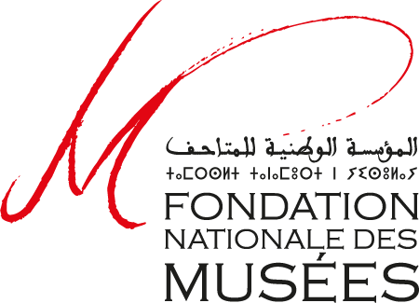The National Foundation of Museums was created in 2011 with the aim of enhancing the Moroccan museum heritage. The Foundation, currently chaired by Mr. Mehdi Qotbi, is an autonomous non-profit organization that manages, on behalf of the State, sixteen national museums, including the Mohammed VI Museum of Modern and Contemporary Art, the National Museum of History and Civilizations and the National Museum of Jewellery in Rabat.

The foundation has many goals related to preserving heritage such as the democratization of culture and preserving the cultural and artistic Moroccan heritage. Its main missions in the field of heritage preservation include archiving, conservation and maintenance, enrichment of collection, support for scientific studies around the collection, and heritage protection against trafficking and illegal export. The National Foundation of Museums promotes museum heritage through its actions of upgrading existing museums and creating new spaces through the organization of temporary exhibitions and cultural events in Morocco and abroad. It also pursues a policy of encouraging visits to museums and promoting Moroccan heritage abroad through international cultural cooperation.

**Abdelkader Damani, Curator of the Rabat Biennale**

Abdelkader Damani is art historian, philosopher, curator and director of the Frac Center-Loire Valley (Orléans, France). He studied architecture in Oran, Algeria before studying Art History and Philosophy at Lyon 2 and Lyon 3 Universities. After managing the art and architecture programs at the Tourette Cultural Center, he directed the VEDUTA platform at the Lyon Biennale from 2007 to 2015. Since 1 September 2015, he has led the Frac Center-Val de Loire. In 2017, he created the Orléans Architecture Biennial and serves as its Artistic Director. The second edition, ‘Our Years of Solitude,’ will open on 10 October 2019. He also served as the curator of the Dakar Biennial in 2014 (Our Common Future, Dak'Art). Known for his multi-disciplinary expertise, Damani was invited to curate the inaugural Rabat Biennale for this work as the Director of Frac Centre Val de Loire and as part of an international partnership between the National Foundation of Museums of Morocco and the Frac Centre.

**Venues**

* Mohammed VI Museum of Modern and Contemporary Art
* Museum of History and Civilizations
* Oudayas Museum
* Fort Rottembourg - Fort Hervé (Borj Lakbir)
* Espace Expressions CDG
* Villa of Arts
* Art Gallery of Crédit Agricole du Maroc
* Art Gallery of Banque Populaire
* National Library of the Kingdom of Morocco
* Mohammed V National Theater
* Hassan II Park

**Associated Venues**

* Gallery en Off
* Kulte Gallery & Editions
* The Cube - Independent Art Room
* Fan Dok Gallery
* Abla Ababou Gallery
* Fathiya Tahiri Gallery

**Institutional Partners**

Ministry of Culture and Communication of Morocco, Academy of the Kingdom of Morocco, Wilaya of Rabat-Salé-Kenitra, Agency for the Development of the Bouregreg Valley, Rabat Development, Bouregreg Culture, Institute of the Arab World, ONA Foundation, CDG Foundation, Cooperation and Cultural Action Service of the Embassy of Spain, French Institutes of Morocco, National Airports Office, Royal Air Maroc, Renault Group, Morocco Post Office, National Tourist Office, Moroccan cinematographic center, Cinematheque Morocco, Crédit Agricole Group of Morocco, Regional Council of Tourism, Regional Association of Hotel Industry.

The Biennale would like to thank the following institutions that have loaned works; AIME – Association d’Individus en Mouvement Engagés, Centre Pompidou, CNAP, Collection Privée Pauline de Mazière, D. Daskalopoulos Collection, Frac Centre-Val de Loire, Frac CAPA,  Institut du Monde Arabe, Marianne Boesky Gallery, Max Meyer Gallery, Musée d’Archéologie de Rabat, Post AG, Shoman Foundation – Darat al Funun, SNRT, White Cube Gallery as well as the artists’ studios.